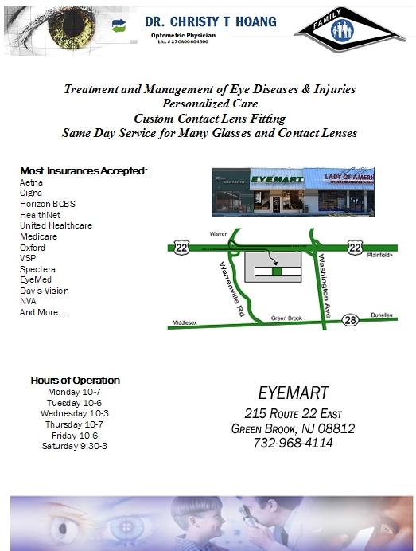
DR. CHRISTY T HOANG

Optometric Physician
Lic.# 270400604500
Treatment and Management of Eye Diseases & Injuries
Personalized Care
Custom Contact Lens Fitting
Same Day Service for Many Glasses and Contact Lenses
Most Insurances Accepted:
- Aetna
- Cigna
- Horizon BCBS
- HealthNet
- United Healthcare
- Medicare
- Oxford
- VSP
- Spectera
- EyeMed
- Davis Vision
- NVA
- And More …
Hours of Operation
Monday 10-7
Tuesday 10-6
Wednesday 10-3
Thursday 10-7
Friday 10-6
Saturday 9:30-3

EYEMART
215 Route 22 East
Green Brook, NJ 08812
732-968-4114

