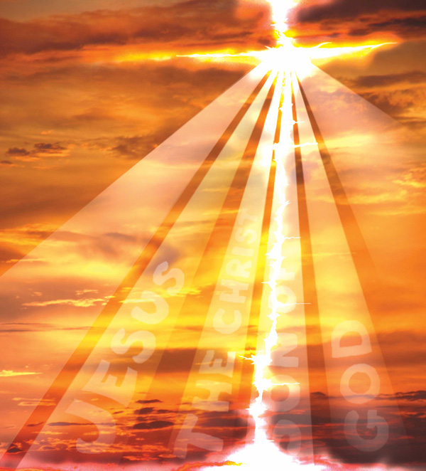  Let Your Light Shine  Ho  ANDREW | Let Your Light Shine  Nguyen  ANH
Let Your Light Shine  Phan  BaoTran | Let Your Light Shine  Nguyen  CHRIS
Let Your Light Shine  Nguyen  CHRISTINA | Let Your Light Shine  Le  CLARA
Let Your Light Shine  Vo  DANNY | Let Your Light Shine  Nguyen  ERIC
Let Your Light Shine  Nguyen  JIMMY | Let Your Light Shine  Vo  JIMMY
Let Your Light Shine  Truong  Katherine | Let Your Light Shine  Lam  Kevin
Let Your Light Shine  Tran  Kevin | Let Your Light Shine  Nguyen  Linda
Let Your Light Shine  Ho  Linh | Let Your Light Shine  Ngo  Linh
Let Your Light Shine  Do  Michael | Let Your Light Shine  Phan  Michelle
Let Your Light Shine  Thi  Monica | Let Your Light Shine  Hoang  NAM
Let Your Light Shine  Nguyen  Nghiem | Let Your Light Shine  Nguyen  Nhan
Let Your Light Shine  Nguyen  NhUnG | Let Your Light Shine  Nguyen  PAUL
Let Your Light Shine  Nguyen  PHIL | Let Your Light Shine  Nguyen  PHUC
Let Your Light Shine  Vo  Richy | Let Your Light Shine  Hoang  SON
Let Your Light Shine  Nguyen  TAM | Let Your Light Shine  Tran  TAM
Let Your Light Shine  Win  THAI | Let Your Light Shine  Tran  THANH
Let Your Light Shine  Bui  THAO | Let Your Light Shine  Cao  Theresa
Let Your Light Shine  Tran  Thomas | Let Your Light Shine  Tran  THU
Let Your Light Shine  Le  Tiffany | Let Your Light Shine  Vu  Tracey
Let Your Light Shine  Pham  Truong | Let Your Light Shine  Tran  VAN
Let Your Light Shine  Hoang  Victoria | Let Your Light Shine  Nguyen  Victoria
Let Your Light Shine  Nguyen  VY | Let Your Light Shine  Nguyen  Vyvian
Let Your Light Shine  Fr. Vu  JOSEPH | Let Your Light Shine  Sr. Maria  LAN
Let Your Light Shine  Nguyen  TUAN | Let Your Light Shine  Thi  TAI

