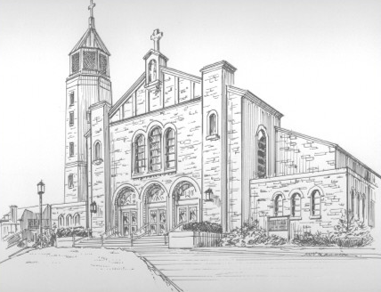St. James celebrates
150 years in town
BY KATHY CHANG
WOODBRIDGE – The 3,500-plus registered families at St. James Roman Catholic Church, which is located on Grenville Avenue, are celebrating 150 years of Parish history.
The faith-filled Irish immigrants working the clay pits in the township founded the St. James congregation in 1860.
There is a lot of love in this community, which is evident by the parish food pantry and social outreach,” Said the Rev. Charlie Cicerale, who has been pastor of St. James for eight years.
In 1878 the Rev. Stephen Bettoni became the first resident pastor of St. Lames Church, and after his death four years later, the Rev. James Devine was appointed by the Bishop of Trenton. Through historical accounts, Devine labored zealously to open a parochial school, and in September 1890 his dreams were realized.
Mitzi Hozjan, chairperson of the parish’s 150th anniversary celebration along with Marge Cena and Krista Cheslak, said she love the Church where she has been a lifelong parishioner.
“I was christened here, I was baptized here, I received all my sacraments here,” She said. “The community is so welcoming, and I am proud of the celebration and I hope the parish celebrates another 150 years.”
The Rev. Richard Farrell was appointed pastor in 1918, and he moved the Church, using tractors, from the Main Street location to Amboy Avenue, which had become a highway. Father Farrell also purchased a house near the school and transformed it into a convent.
In 1937 the Rev. Charles McCorristin expanded the school and launched a campaign for a new Church building.
Tow years after Father McCorristin died, the new Church as dedicated on June 23, 1968. The new St. James is Romanesque in architectural design. The exterior is Pennsylvania stone with rose and buff shades, and the arches over the door are made of limestone. The building has a seating capacity of 1,200.
On Nov, 13 the parish invited the Rev. Alphonse Stephenson and the Orchestra of St. Peter by the Sea to perform a concert in front of a packed audience.
Elizaberth Golubieski has been a member of the parish for over 50 years, as have her five children.
“This is a good parish to belong to,” she said with a smile.
Upcoming events in celebration of the 150 years include a parish mission on Feb. 14-16, a mardi Gras celebration on Feb. 16, a McCorristin Hall after the mission, a pilgrimage to Italy on March 15-25, “A Taste of St. James” on April 18, a 150-year anniversary Mass with a reception in McCorristin Hall on May 2, a Barron Arts Center historical display of the Church on May 1-16, an event reception at the Barron Arts center on May 7, an outdoor Mass and parish picnic at Warren Park on May 23, a “Pillars of the Church Luncheon” in June , a pilgrimage to Washington, D.C., in September, and a closing Mass on Oct. 10.

