St. James Catholic Church
148 Grenville St Phone 732-634-0500
Woodbridge NJ 07095-1812 Fax 732-602-1487

Dear St. James Vietnamese Catholic Community,
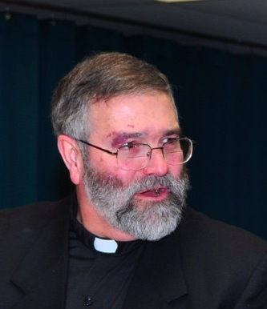
Peace be with you this Jubilee New Year, a year of Grace for all of us as we celebrate the 150th Anniversary of the founding of our parish and 50 years (1960-2010) of the Vietnamese Conference of Catholic Bishops.
The major event of this year for the Vietnamese Church is the 350 year memorial of the establishment of the first two dioceses in the country (North and South Vietnam). But as you well know, the Holy Spirit was at work in the faithful Vietnamese men, women and children to draw them ever closer to Jesus Christ long before that. You have a great tradition of faith, hope and love and so, with great joy, we celebrate the beginning of the practice of your faith here and at home!
There is an old Eastern saying:
“In the end what matters most is...
How well did you live?
How well did you love?
How well did you learn to let go?”
At the beginning of a new year it is helpful to “keep the end” in mind. As you gather to thank God for the gift of another year to sing His praises, to worship Him in song and dance and ritual, to listen and respond to His Holy Word, to take the Sacraments of life, to gather and enjoy community life with its challenges and gifts--- all this will help us to live, love and continue to let go! To let go of past hurts, resentments, heartaches and to say ‘yes’ to the lessons the past teaches us in this present moment; so we might move on to know ever more deeply God’s great love for us. As St. Augustine said: “It is one thing to see the land of peace... and it is another thing to tread the road that leads to it.”
Have courage at the start of this year and know that I pray for you each day, morning and night that God will bring to completion the good work God has begun in you.
As this year unfolds let Mary, the Mother of God, Our Lady of La Vang, teach you to ponder as she did, the weighty matters you do not understand or cannot comprehend. May you grow in believing that nothing is accidental; all is providential for one who puts their faith in her beloved Son. Mary is the image for all of us, an image of one who listens to others, and searches the Scriptures to find the Light, the Truth and the Peace of God.
St. Bernard of Clairvaux, monk and mystic, wrote: “Now in the deep womb of the Sacred Word I will search for myself and for Spirit and Truth.” As we begin this year of Grace, hopefully we will begin to listen closely to other’s experience of God and to other communities revelations and praise of God; hopefully we will take what they have known and learned to heart so that this Jesus, the fullness of God in flesh and blood and Word, may continue to make us holy, save us and the world, and bless us with peace. I love you dearly.

With every grace and blessing,

Fr. Charlie Cicerale
Pastor

