TO THE NEW LAND
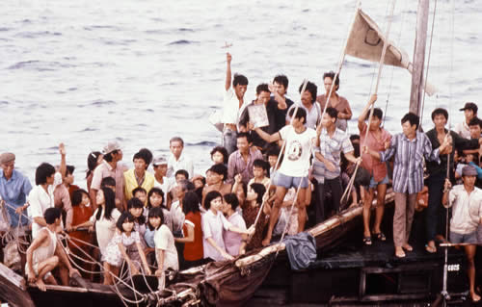This poem describes how my Dad escaped Vietnam to come to America, Victoria, 12
They stood there at midnight, all around them was black,
They stared at the ocean, each with bags on their back,
They're leaving their country, their fates in God's hands,
As they eagerly wait to get to the new land,
A man in a small boat rowed to the shore,
As the boys climbed in, each grabbing an oar,
Soon enough they reached a bigger boat,
Which they quickly boarded, not a word from their throat,
They were put in the bunker and told not to make a noise,
As they tried to lie still, squished between many other boys,
Suddenly a gunshot pierced through the air,
Putting fear into the hearts of those who were there,
Then the waves started to rock, quickly to and fro,
As saltwater poured into the bunker below,
The boys stayed in the bunker for six to eight hours,
As the waves of the ocean roared with such power,
Then they came out from below, and looked out at the sea,
Not sure whether to smile or cry for they were homesick but free,
They dreamed of the new land, called USA,
Hoping they'd get there soon as they silently prayed,
At first the water was calm but then the waves got real high,
The fear of this sight caused grown men to cry,
The captain acted fast and tied everyone to the boat,
Silently hoping to himself the ship would stay afloat,
Dark clouds passed over them, quick as can be,
As the rain and the wind nearly threw them into the sea,
Although it took a while, the storm finally passed,
Everyone was still in horror, their faces aghast,
After the storm there was hardly any water or food,
This put everyone in an even more horrible mood,
Only one inch of water was allowed every day,
As the captain tried to get water to last the whole way,

But soon enough they were out of gas,
So they looked out not wanting any land to pass,
They finally saw land out in the sea,
So they tightened their sails and got there quickly,
The natives there looked like communists in Vietnam,
So they almost ran away trying hard to stay calm,
But the people said they weren't Vietnamese but Chinese instead,
So the boys came back and not one of them fled,
Then the Chinese gave them something more valuable than gold,
A cup of water, refreshing and cold,
They stayed at the land for one and a half years,
Until they received a letter that quickly sprung tears,
Their family was in the USA,
So they knew they could no longer stay,
So they’re on a plane with their bags in their hands,
Knowing that finally they would get to the new land.
GRANDPA

The oldest and the wisest in my family
is my grandpa who loves and cares for me
His age is eighty five
We're all glad he's still alive
He's the smartest and the best at poetry
Even though he's the oldest on our family tree
I will love him even after he dies
For he is the man I'll always idolize.
Victoria, 12

