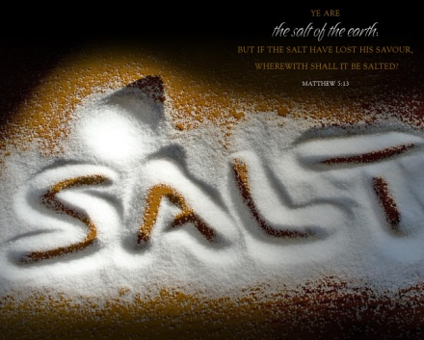**Về thăm Việt Nam**

Mary Trúc Lâm Lê  
trường Việt Ngữ

Mùa hè năm nay, con được đi về thăm quê hương Việt Nam. Lúc con về con thăm ông, bà, cô, chú, bác và anh chị họ của con.

Đây không phải là lần đầu tiên con được về Việt Nam đâu, nhưng vì lần này những kỷ niệm êm đẹp đó con còn nhớ được. Chiều chiều, cô Út chở con đi vòng vòng thị xã Bình Dương, cô dẫn con đi ăn phở, ăn mì Nam Vang.

Lần về Việt Nam này, con được đi chơi ở nhiều nơi. Con được đi Vũng Tàu, Suối Tiên, Đầm Sen, và Đại Nam. Ở đâu cũng đẹp và vui cả, con thích đi tắm biển ở Vũng Tàu nhất.



Cũng trong lần này, con được ăn rất nhiều trái cây như trái măng cụt, sầu riêng, xoài, và con cũng được uống nước dừa nữa. Con rất yêu mến Việt Nam, hy vọng con sẽ có cơ hội về thăm Việt Nam trong vài năm nữa.

Cũng trong lần này, con cũng hiểu là tại sao ba mẹ con cho con đi học tiếng Việt. Vì con nói được tiếng Việt nên con không cần phải có ba mẹ luôn ở bên cạnh để dịch ra tiếng Mỹ cho con, con cũng hiểu khi ông bà thăm hỏi con. Con sẽ cố gắng học thêm tiếng Việt để khi con lớn lên con sẽ về Việt Nam đi thăm ông bà một mình.Muối

Đất

Muối Đất which means Salt Of The Earth (SOTE) is a youth group in the Vietnamese Catholic Community at St. James Church. We are involved in many aspects of the church and partake in various activities. For example, every three months we organize a youth mass where young people involves in the readings, the youth choir, the petitions, the collections and the offer of the gifts. It is very satisfying to see so many young people taking part in the church. Members meet every once in awhile to discuss religion as a family where everyone is welcome and together we grow and help each other through everything. If one of us is down, together we lift them up because that's what families do.

Also as a Catholic youth group, we try to learn about and grow closer to God every day. An example is this past October, Monica, Vyvian and Andrew represented Muoi Dat at a gathering for YAYA (Youth and Young Adults) in Pennsylvania. The gathering took a weekend but it was one of the most memorable. They were able to meet new Catholic friends, and have a good time playing games while getting closer to God every day. At the gathering, there were group discussions, daily Mass, parying time and by night entertainment, all activities were well planned and interesting. The theme at the gathering was “Magis.” Sounds a lot like Magic, right? That is because God does magical things. They were able to define themselves while meeting new people, and get more answers about their religion. Sometimes, the youth needs a little getaway retreat instead of going to church every Sunday. It helps them realize that there is more to God than just Mass every Sunday, Christmas, or Easter; and Muoi Dat helps with that!