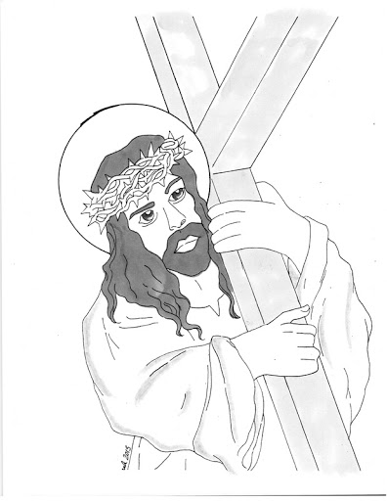

God

Grace Nguyen

*He greets me with light every morning,*

*I open the curtains to see His beaming smile,*

*I pull the windows open to breathe the air He gives,*

*I am ready to conquer the day in His name.*

*When I stumble and trip, people will glance-*

*ask a quick “are you okay*?*” but they leave,*

*taking more value in the illusion of Earth,*

*and forgetting about me.*

*But He is unconditional love,*

*the love you will never receive from a human being,*

*the love that gives you more power to do*

*whatever you desire,*

*the love that sets you free from the barriers,*

*the chains gripping your wrists and legs,*

*holding you back.*

*Not only unique, but eternally merciful is He.*

*Nothing is more important than your praise towards Him.*