Tết Nguyên Đán

**Angelina Thảo Vy Nguyễn**

Tết (short for Tết Nguyên Đán) is one of the most important holidays for Vietnamese culture! It is called Lunar New Year in English. It occurs in February. Depending on the year, we know when Tết occurs. In 2022, it will occur on February 1st and will last for 9 days. There are 12 Vietnamese zodiac signs. The Rat, Buffalo, Tiger, Cat, Dragon, Snake, Horse, Goat, Monkey, Rooster, Dog, and Pig. It will be the Year of the Tiger. Tết means feast for the first morning. Bánh chưng is one of the things we eat on Tết. Children receive “lucky money” in red envelopes. We wish everyone a prosperous year. Vietnamese people believe that what you do on the first day of the year will affect the rest of the year. We visit relatives. We worship our ancestors. Children and the elderly receive “lucky money” in red envelopes. We stay devoted to study with wishes from our grandparents and parents with the “lucky money”. In previous years before COVID, we always dance and sing for others to watch. This coming Tết, we will perform in the hall. Chúc mừng năm mới! ◼

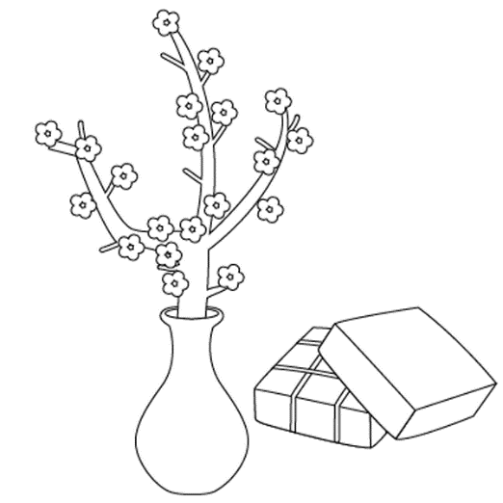

Tet Poem

**To Nghi/Adela**

*Tet, or Vietnamese New Year, is a time where we prepare for a new chapter.*

*We ask God to give us a better year,*

*to spend and to embrace the beauty*

*of God's creations.*

*I appreciate the wonderful surroundings during Tet.*

*The flowers in fields,*

*the dances of the dragons,*

*and the traditional Vietnamese foods*

*brought to us by kind people.*

*As I walk by during Spring,*

*I wonder why flowers blossom so much.*

*Does Tet make God smile*?

*I see an image near a lake,*

*waiting to entice someone nearby.*

*There was a lady with a long dress,*

*wearing a traditional Vietnamese hat.*

*She laid beside the waters,*

*and talked to God from above.*

*Here comes a brand new year,*

*lots of new things to explore.*

*A clean, blank slate to write on,*

*Fun happenings galore.*

*To you we wish the best of things,*

*All the blessings a new year brings.* ◼

