Tết

A Perfect Celebration

**By Janie Bui**

Tết Nguyên Đán, or Tết, is a Vietnamese holiday celebrating the Vietnamese new year. Being around for as long as the I8th century B.C, the celebration typically lasts 3 days with many festivities such as lighting firecrackers, eating cultural cuisine, and my personal favorite, receiving lucky money (also known as lì xì)!

While there are many activities and traditions that take place during Tết celebrations, there are also traditions that revolve around the preparation of the party, like the cleaning of houses. The meaning behind this seemingly strange tradition is that Vietnamese people believe that cleaning your house will drive bad spirits and demons out. It is also believed that wearing bright colors, especially red and gold, will do the same.

Family reunion is a classic Tết tradition. Families gather for about the same reason families do on Christmas; to enjoy a laugh, a conversation, and some delicious food!

Speaking of food, there are many, many, many, many, MANY, traditional foods eaten during Tết. Examples would be sticky rice cakes, also known as Bánh Chưng, Mứt Tết, which is a mixture of candied fruits, vegetables, nuts, custard candy, and different seeds on a tray, and Thịt Kho Trứng, pork belly and eggs lightly fried in a tasty, sweet “coconut water, chili, aromatics, and fish sauce” broth.

There are also specific colors that you should wear on Tết. Like I mentioned earlier, you should probably wear red or gold. Red represents luck, while gold stands for wealth. Red is also meant to be the color that demons fear most, as I’ve said.

**Additional Facts:**

- Kids do not have school on Tết; they typically have a week off, and they don’t have any other breaks besides summer break!

- Parents often buy them and their kids new clothes, such as áo dài. This is to welcome the new year. Just like you say on New Years, “Out with the old and in with the new!”

- As well as going to visit family, people often visit their hometowns. Because of this, you’ll often find normally crowded cities very empty and the countryside and small villages very crowded!

Thank you for reading this and I hope you have learned a thing or two. **Chúc mừng năm mới!!!!** ◼

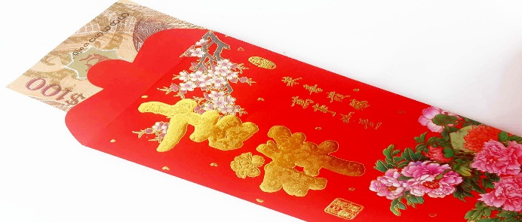

*Information gained in various websites, as well as Google searches