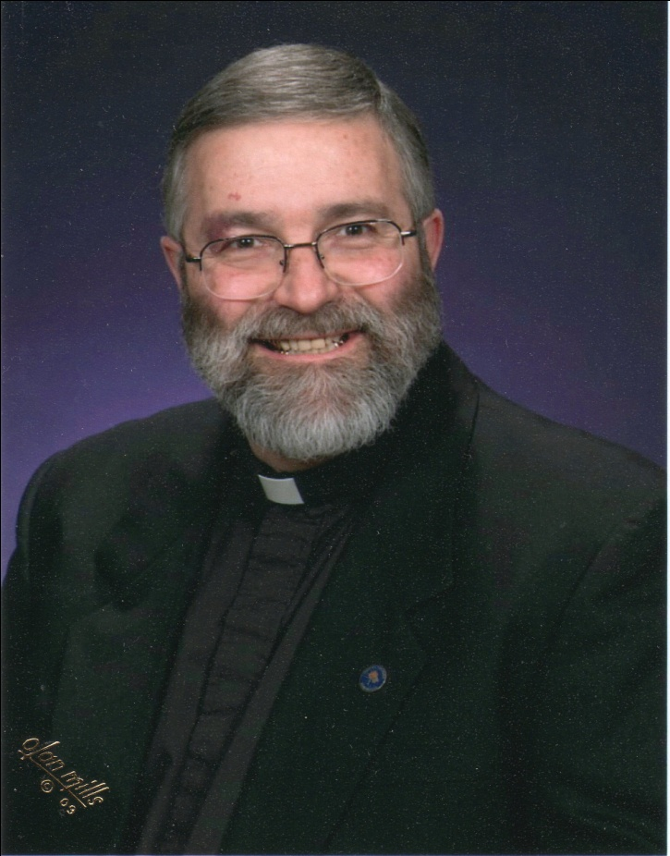

May need to photoshop/lighten the picture to make it printable in B&W

Add Congratulations to Fr. Charlie to his elevation to the title of Monsignor by Pope Benedict XVI

Installation Mass On date at St. Francis

Thanksgiving Mass at St. James at 12:00 noon on February 12th, 2012