Cộng Đoàn 25 Năm (1987 – 2012)

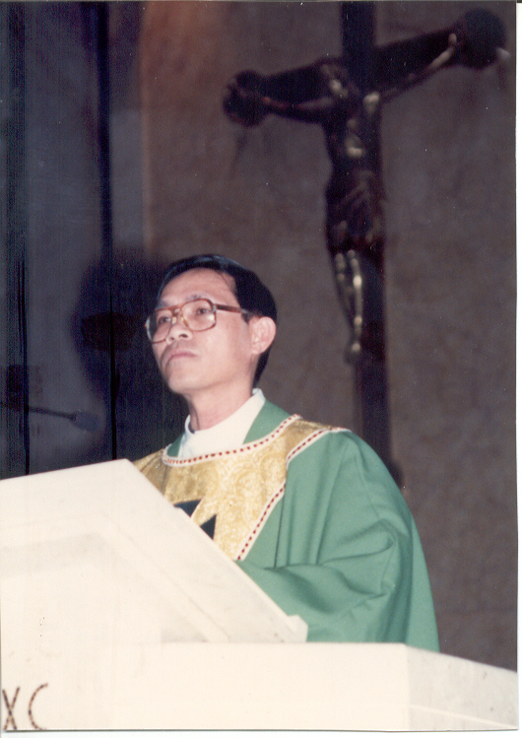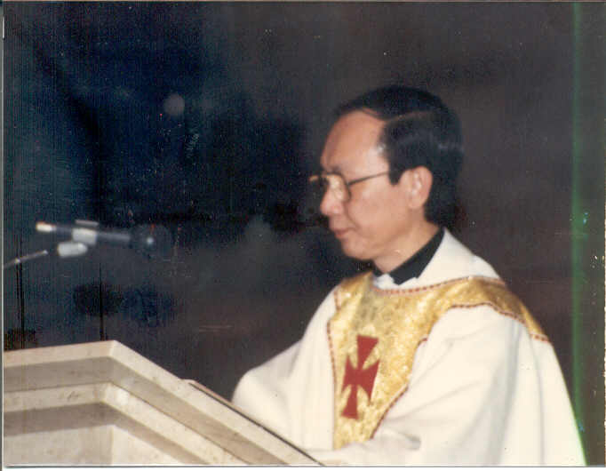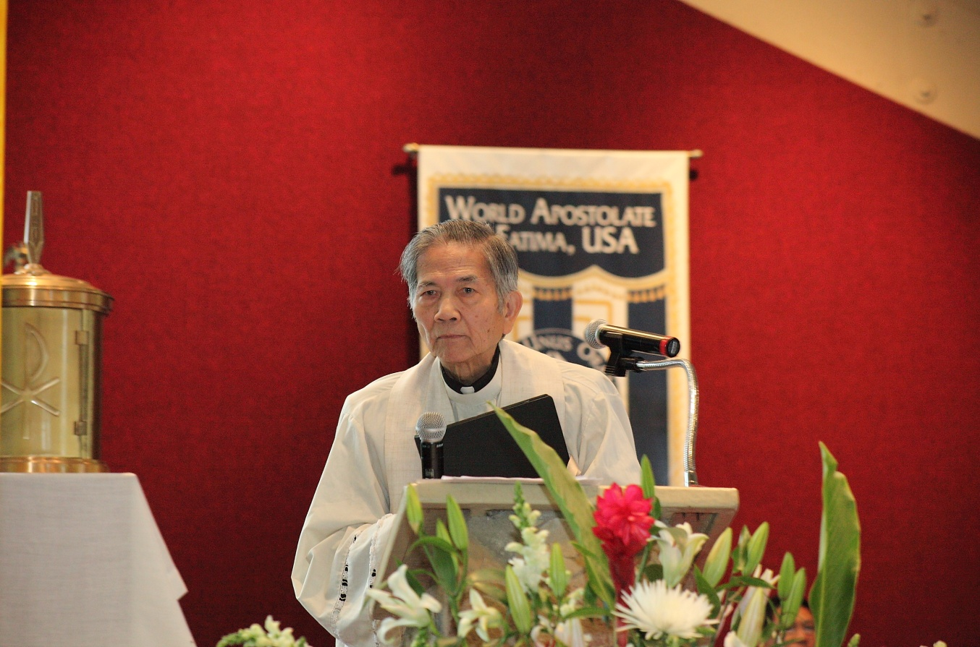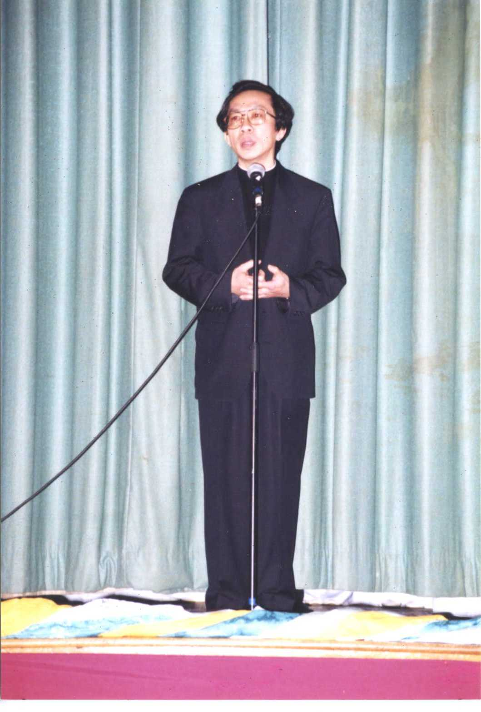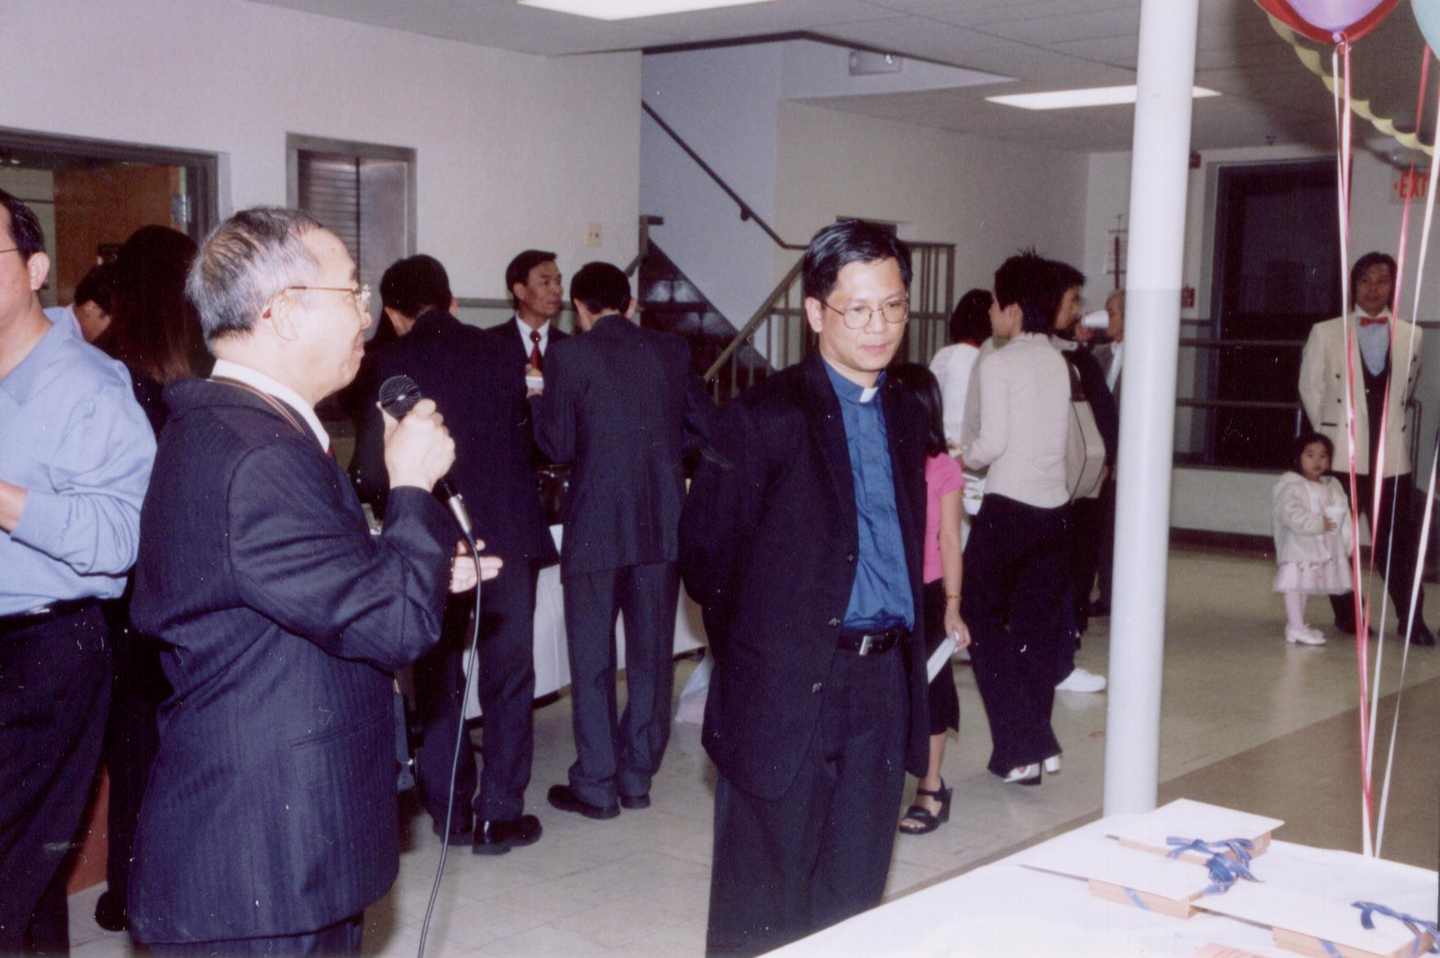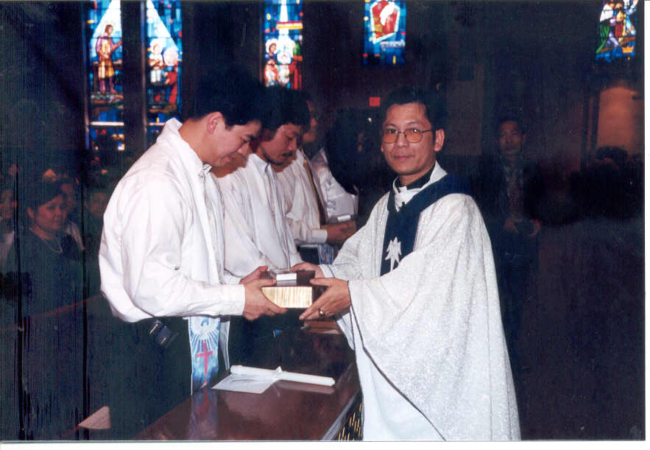

|  |  |  |  |
| --- | --- | --- | --- |
| C:\Users\Linh\Desktop\HinhCD\1989\1989 (67).jpg | C:\Users\Linh\Desktop\HinhCD\1992\Picture 160.jpg | C:\Users\Linh\Desktop\HinhCD\1993\094.jpg | C:\Users\Linh\Desktop\HinhCD\1994\102.jpg |
| C:\Users\Linh\Desktop\HinhCD\1996\CD_1996_201.jpg | C:\Users\Linh\Desktop\HinhCD\1996\CD_1996_279.jpg | C:\Users\Linh\Desktop\HinhCD\1995\046.jpg | C:\Users\Linh\Desktop\HinhCD\1997\Picture 125.jpg |
| C:\Users\Linh\Desktop\HinhCD\1997\Picture 069.jpg | C:\Users\Linh\Desktop\HinhCD\1998\CD1998 187.jpg | C:\Users\Linh\Desktop\HinhCD\1998\CD1998 070.jpg |  |
| C:\Users\Linh\Desktop\HinhCD\1997\Picture 168.jpg | C:\Users\Linh\Desktop\HinhCD\2000\027.jpg | C:\Users\Linh\Desktop\HinhCD\1999\135.jpg | C:\Users\Linh\Desktop\HinhCD\2003\xuan hy vong 076.jpg |
| C:\Users\Linh\Desktop\HinhCD\2002\051.jpg |  | C:\Users\Linh\Desktop\HinhCD\2004\Tet - Vu 8.jpg |  |

