Friends

Hien Nguyen

People you meet,

Who change your life.

People who are clowns,

Make you laugh to death.

People who are rainbows,

That shine after the rain,

And cheer you up.

Sometimes,

They fade,

And leave….

Friends-

People who are backstabbers,

Leave you in the dark.

People who ignore,

You don’t get why.

They stop talking,

They’re mad,

They don’t tell you why.

Your only question,

“What happened,

To our friendship?”

Friends-

People you remember,

Their actions influence you.

They either stay,

Or disappear….

God

Hien Nguyen

A spirit,

Full of wonders.

His works,

Are mysterious,

Hidden,

No one shall understand.

King of all,

Such a kind,

Merciful Father.

He forgives,

And replenishes.

He gives us bricks,

We build houses.

He gives us paper,

A pen,

We write.

He opens the door,

We enter.

He gives us books,

We read.

He gives us instruments,

We play.

He is the foundation,

Of life.

The Ocean

Hien Nguyen

The gentle, blue waves wash up my feet,

I stretched my legs onto the sand.

As I sat,

I admired the water flowing up my limbs.

I feel its refreshment,

I am calm.

The gateway,

Leading another world.

God's creation,

Of a different life.

Unbelievable deep sea,

Full of imaginary creatures,

We've never seen before.

I feel its tranquil presence,

Below the soft sky and breathtaking sunset.

The vast ocean

My beloved home.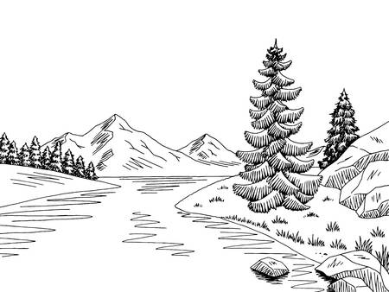

The Stream

Tác giả: Hien Nguyen

I see the stream,  
From forests away.  
It shimmers underneath  
the bright sun.  
My mouth thirsts,  
For such clean water.  
  
I run,  
As fast as  
I can.

My stamina dies.

I pant,  
Yet,  
I have made it.  
I see my reflection  
And smile.  
  
  
I wash my face.  
The water refreshes me.  
God has given me  
A miracle.  
I will survive.